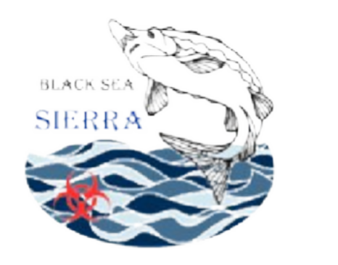

Black Sea SIERRA Project

SELECTION NOTICE FOR ONE EXPERT TO SUPPORT THE ELABORATION OF THE HANDBOOK ON MARINE POLLUTION ASSESSMENT METHODOLOGY AND SOURCES, INCLUDING ARMED CONFLICTS FOR THE BLACK SEA REGION.

Project 101124670

Attachment A Application Form

The undersigned Born in on Resident in , street Telephone number
E-mail
Fiscal code

Requests to be admitted to participate in the selection of one Expert to support the development of a technical handbook on marine pollution in the Black Sea Basin and, for this purpose, declares:
- to be a/an citizen;
- to enjoy civil and political rights in ;
- that the information provided in the curriculum vitae is truthful, aware that – pursuant to art. 76 of the Presidential Decree December 28, 2000 n. 445 – false declarations and the use of false documents are punishable under the Penal Code and special laws.
Educational Qualification:
- Bachelor's degree in:
- Other

Education, General Experience and Technical Skills
- Proven knowledge in marine pollution, environmental science, or related fields
- Strong analytical and organisational skills
- Ability to synthesise complex data and contribute to structured technical documentation
- Excellent scientific and technical writing skills
- Ability to work independently and in coordination with project teams and experts
- Good reporting and documentation skills
- Good command of English (written and spoken)
- Good knowledge of MS Office tools (Word, Excel, etc.)
- Academic background in Environmental Sciences, Marine Sciences, Biology, or related disciplines
- Previous experience in EU-funded or international projects is considered an asset
- Experience in data analysis, environmental monitoring, or pollution assessment methodologies

Technical Expertise – Marine Pollution Handbook Development
- Proven experience in drafting scientific or technical publications (reports, studies, handbooks)
- Knowledge of marine pollution assessment methodologies and pollution sources
- Ability to integrate and analyse data from sampling activities, laboratory analysis, and environmental monitoring
- Understanding of environmental impacts, including those related to anthropogenic pressures and conflict-related pollution
- Ability to ensure clarity, consistency, and scientific accuracy across complex technical documents
- Experience in developing harmonised methodological frameworks

Coordination and Collaboration
- Ability to collaborate with multidisciplinary and international teams
- Experience in coordinating with project partners and stakeholders
- Capacity to meet deadlines and manage deliverables efficiently
- Availability to interact with the ARCES project team and contribute to the development of the final publication

The undersigned declares to possess the required educational qualifications:

The undersigned further declares to possess the relevant experience and knowledge applicable to this call:

The undersigned consents to the processing of personal data in accordance with Regulation (EU) 2016/679 (GDPR) and applicable national legislation.

Attachments
- Curriculum Vitae (in English)
- Copy of valid ID document

Signature – Date

